Gretchen Everhart School

VISION /MISSION / BELIEF STATEMENTS

Striving for quality of life…….
One student….
One success at a time.

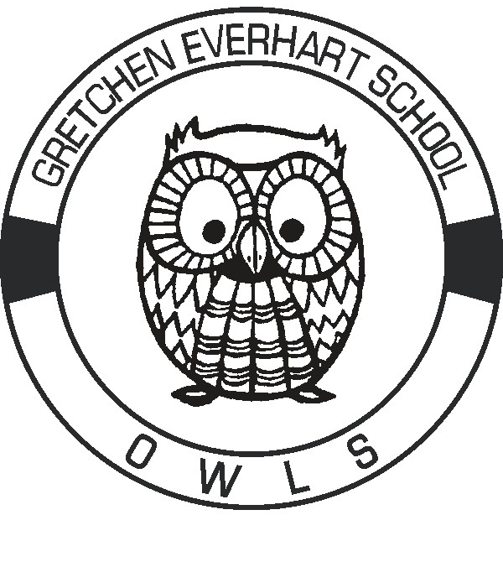
We believe that each individual is unique, differing from all others in types of attributes and degree of endowment. Each individual should be allowed to grow and develop to his/her greatest potential intellectually, physically, socially and emotionally.

We believe that educational programming should be designed to meet the needs of each student as an individual, rather than trying to fit the student into already established programs.

We believe that it is the joint responsibility of the home, school, and community to cooperatively provide the environment and experiences to enable each individual to develop his/her maximum potential.

